**Daily Scrum or Standup Meeting**

Team name: 5th Element

Scrum Master: Leonardo Craven

Date: November 1, 2021

| **Team Member** | **What did you do since the last scrum?** | **What do you plan to do before the next scrum?** | **What obstacles do you have?** |
| --- | --- | --- | --- |
| Leo | Worked on scorecard page | Work on (finish) scorecard page | None |
| Gavin | Worked on leaderboard page | Work on (finish?) leaderboard page | None |
| Andrew | Brainstorm UI improvement ideas | Brainstorm UI improvement ideas | None |
| Brock | Worked on registered tournaments page | Finish registered tournaments page | None |

# Burndown

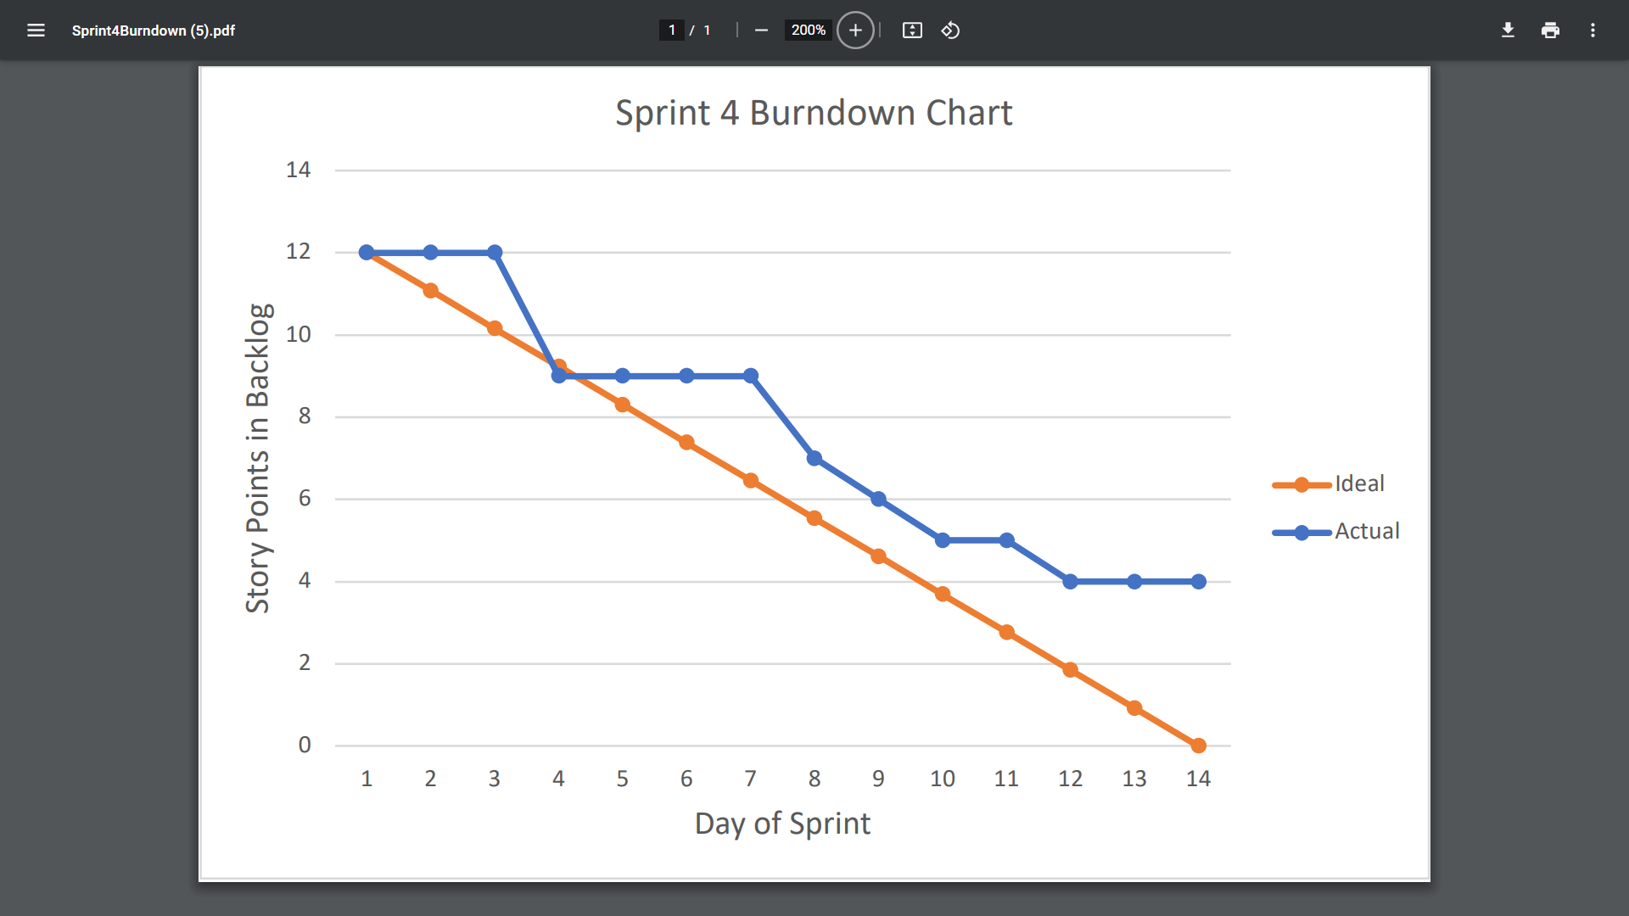

# Screenshot of you project board

